Debugging Log

# Defect Information

**Defect ID:** Bug 2: Incorrect fine amount levied

**Priority:** Major

**Status:** RESOLVED

**Last updated:** 2020-10-18

**Assigned to:** Sam Johnson

## Reported Issue

When a fine is incurred, the amount of fine reported is half the amount intended.

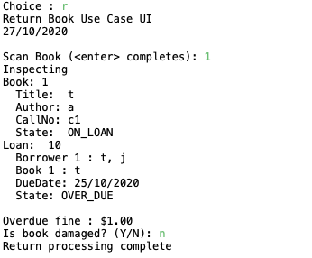

# Replication

## Setup

* Patron created with data as per Test Data
* Patron state is CAN_BORROW
* Patron fines are below fine limit
* Book created with data as per Test Data
* Book state is AVAILABLE
* Recorded Patron ID and Book ID

## Tear down

* Remove library.obj file

## Steps

|  |  |  |
| --- | --- | --- |
| **#** | **Test Action** | **Expected Results** |
| 1 | Enter ‘L’ at the main menu, and press Enter | Borrow Book use case UI starts. Prompt to swipe Patron card. |
| 2 | Enter Patron ID, press Enter | Prompted to scan book. |
| 3 | Enter Book ID, press Enter | Prompted to scan another book. |
| 4 | Press Enter | System displays Final Borrowing List. Prompts to Commit Loans. |
| 5 | Enter ‘Y’, press Enter | Completed Borrowing List displayed, prompted to enter any key to exit. |
| 6 | Press Enter | Main menu displayed |
| 7 | Enter ‘T’, press Enter | Prompted to enter the number of days |
| 8 | Enter Number of Days (4), press Enter | Displays new date followed by main menu |
| 9 | Enter ‘R’, press Enter | Return Book use case UI starts. Prompt to scan book. |
| 10 | Enter Book ID, press Enter | Displays inspecting book, book details, and loan details. Prompted to confirm if book is damaged.  Bug evident: Loan State is OVER_DUE Overdue Files is $1.00 |
| 11 | Enter ‘N’, press Enter | Main menu is displayed |

## Test Data

| **Description** | | **Data** |
| --- | --- | --- |
| Patron 1 | Last name | Mustermann |
| First name | Max |
| Email | max.mustermann@example.com |
| Phone | 123456789 |
| Book 1 | Author | Herman Melville |
| Title | Moby Dick |
| Call Number | c123 |
| Number of Days | | 4 |

Cannot replicate bug after Bug 1 has been rectified. Display of incorrect fine amount was caused by incorrect MILLIS_PER_DAY constant.

